**Examining the Success of a Prototype of High School Mathematics Course**

**Ben Harwood**

**Introduction**

As the previous two decades (and even longer) have proven, a great number of high school students lack the basic mathematical survival skills needed for adulthood. This can, unfortunately, be seen easily enough at a fast food restaurant when the cash register quits working properly and the clerks are unable to even determine a customer’s change[1]. As we, as a culture, continue to be more and more reliant on technology for just about everything, this inability to perform, in some cases just basic arithmetic, can be very problematic when technology fails or breaks.

In early 2018, the Kenton County School District (KCSD from here on) in KY voted to implement a new mathematics course in its high schools for the following school year. This course was unique in that it was not just a mathematics course, but a mathematics course disguised as a life skills class (or perhaps, the other way around). The course was designed to provide students with some exposure to mathematical concepts that arise more frequently in every day life as an adult, with the idea of ensuring they are equipped to handle being an adult after graduation. Topics such as basic finance and budgeting, as well as things more involved like car purchasing. Throughout the course various speakers were invited as guest lecturers to provide actual real-world examples and exposure to the topics they were discussing. For example, during the unit on car purchasing a car salesman (who conveniently studied mathematics in college) was brought in to explain the different ways cars can be purchased and went through the mathematics used to calculate loan and lease payments.

With the blessing of the state education department, this course was deemed mandatory for that school year, and so each of the five high schools in the district offered enough sections of the course to ensure they could accommodate all of their students. As an additional experiment, the course was self-paced, meaning the students had the flexibility to submit assignments at their own pace, much like an online graduate program. It was decided before the semester began that ¾ of the way through the semester a study should be conducted to see how students were adapting to this style. This is the goal of the current paper.

**Section 1: Analysis and Models**

First, some additional context. There are five schools in the district, henceforth named A, B, C, D, and E. The bigger schools, A and B, had over 10 sections of the course, while the smaller school C had three sections and the yet smaller schools D and E had only one section.

**Subsection 1.1: About the Data**

In order to conduct the study, KCSD provided a small data set that reported how well students were keeping up with their work. The students’ progress was binned into six variables:

* Very ahead (more than 5 lessons ahead)
* Middling (5 lessons to 0 lessons ahead)
* Behind (1 to 5 lesson behind)
* More Behind (6 to 10 lesson behind)
* Very Behind (more than 10 lessons behind)
* Completed (all work complete)

An additional variable was created named “Enrolled” that was the total number of students in each section (simply the sum of the other variables for each section). Additionally, the variable names were quite long, and were shortened for ease of display[2]. Below is a snapshot of the data having done this, followed by summary descriptive statistics: 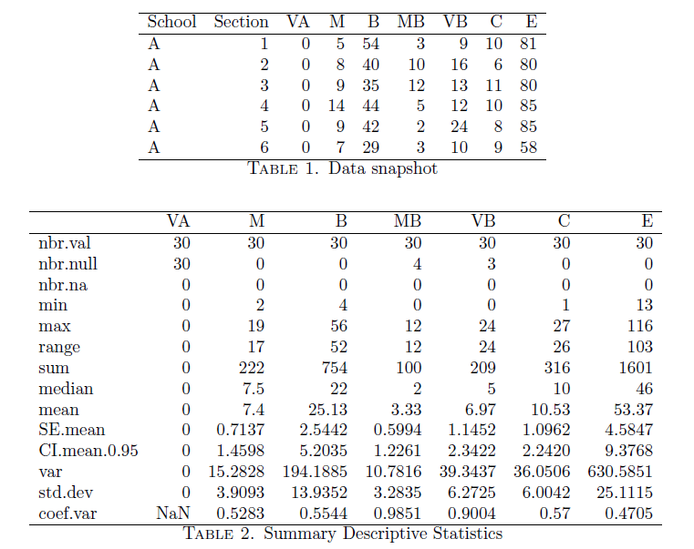

No additional cleaning was required, as no outliers or missing values were present (notice the nbr.na row in Table 2 indicating no missing values, the “null values” displayed in the nbr.null row are true 0’s, indicating no students for the particular section fell into that particular bin). Subgroups of the data were formed based on the schools to allow for focused examination of each school. As an example, the following graphic shows how many students fall into each bucket for school A, by section.

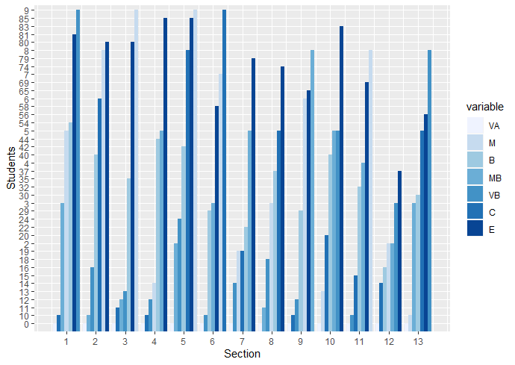

The astute reader will notice that this is not especially enlightening, so instead consider the following that shows the total number of students in each progress level for each of the five schools (note that the number of enrolled students is not included, as for the present moment it holds no value).

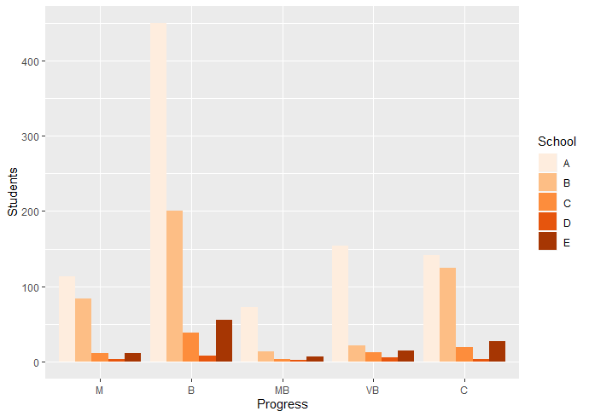

The data can be yet further better seen in the following, which is the previous display but reversed, showing the data grouped by school then by progress level[3].

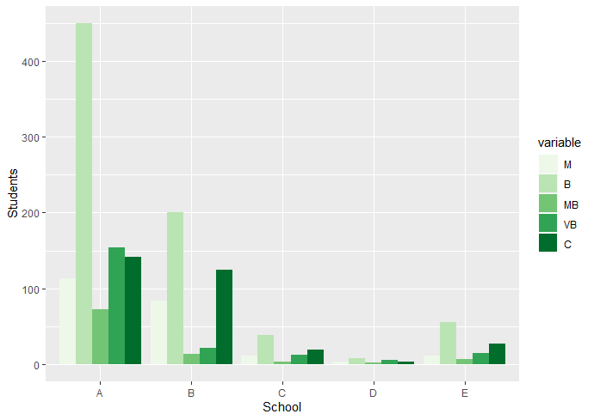

This, combined with the following table, begins to provide insight into the data as the two show the very distinct differences in the enrollment (due to the size of the schools), but also spurs the continued analysis in the next subsection.

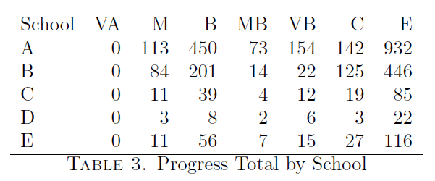

**Subsection 1.2: Analysis**

Given the range of enrolled students across the five schools, looking at the overall number of students would not shed full light on the nature of this dataset. As such, consider the percentage of enrolled students in each bin for the different schools as shown in Table 4:

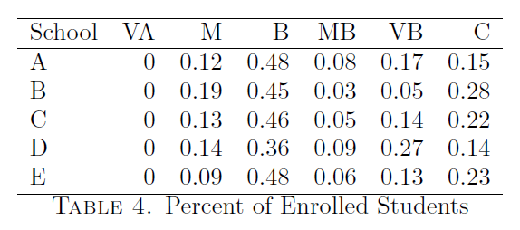

While this technically shows the same information as Table 3, it is more telling of the overall picture and certain conditions can be drawn immediately:

1. School B is the “winner” when it comes to overall progress, as they had the highest percentage of students already complete and 53% of the enrolled students were behind which is at least 12% better than the other schools.
2. The two smaller schools, D and E, were just as susceptible to students falling behind as the others.

Being that this data was collected at the ¾ mark, that would leave approximately nine lessons before the semester ended, and roughly four weeks in which to finish them. Those students in the ‘Behind’ bin were probably ok, as being less than 5 lessons behind should not have been overly difficult to overcome. However, those students who were ‘More Behind’ or ‘Very behind’ (a total of 19% of all students) had at least 15 lessons to complete in the last four-week period. The ‘More Behind’ students had completed 17 to 22 lessons at this point, a rate of 4.53 to 5.87 lessons per week. With 4 weeks remaining, assuming they kept up this rate, this group SHOULD have ended up getting everything in on time, as 18 to 23 lessons would have been completed in this final ¼ of the semester. The same cannot be said of the ‘Very Behind’ group, as they had a completion rate of, at best, 4.26 lessons per week, and assuming the same rate of completion would mean those students would complete 17 more lessons my semester end. However, these students were more than 10 lessons behind, and there are 9 remaining. At minimum 19 lessons would have to be completed in order for the ‘Very Behind’ students to get all the required material finished, which without additional effort would not be possible.

To get a better understanding of what the data means, ANOVA was conducted for each variable to investigate progress differences by school, with follow-up analysis using the Scheffé post-hoc test. Discriminant analysis was conjectured as a potential option, however due to multicollinearity (as evidenced by the correlation discussion in the following section) this approach was quickly dismissed.

**Section 2: Results**

*Please note: The bin “VA” is omitted for the remainder of the discussion as it has no non-zero entries.*

As mentioned in section 1.2, discriminant analysis was initially attempted to predict whether school could be predicted by a combination of the progress bins. However, as evidenced by the following correlation heatmap, multicollinearity was an issue. Intuitively, this should come as no surprise, as each variable is essentially a count of “yes” responses for each section if it were broken down to individual students, and a “yes” for one bin variable means a “no” for every other bin variable.

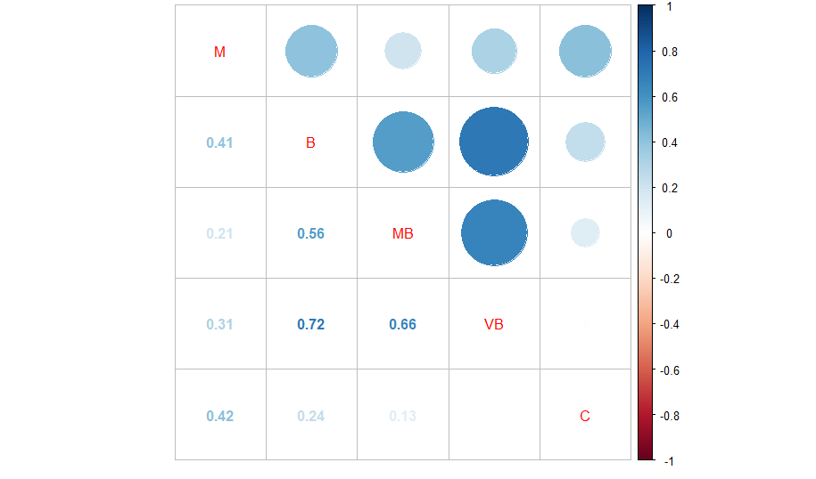

Having been defeated by multicollinearity, ANOVA was pursued. There were five separate ANOVAs performed, one for each progress variable. No additional cleaning was required as ANOVA is robust against violations of normality. First, Levene’s Test for equal variances is presented in Table 5 and indicates homogeneity of variances for each variable (it could be argued that Levene’s Test failed for “MB”).

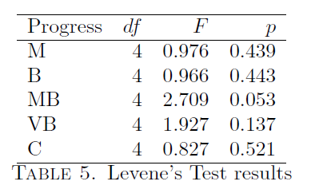

Factor interactions can be seen in the following image.

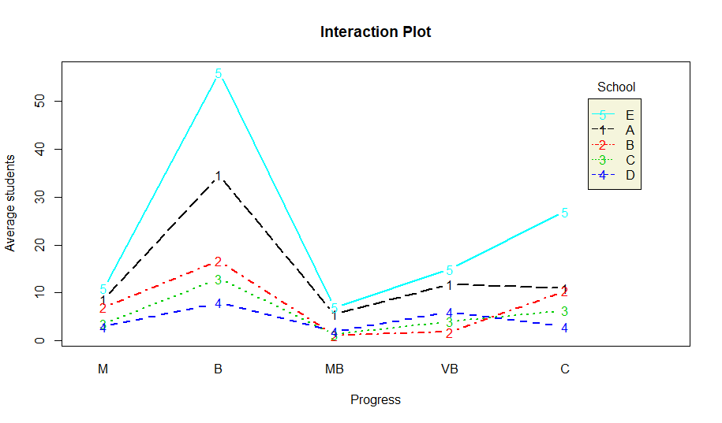

The one-way analysis of variance was conducted to investigate school differences in each of the five progress variables. ANOVA results, presented in Table 6, show significant effects for each level of progression except for middling (*F*(4,25)=1.769, *p*=0.167, partial *η2*=0.221). Each of B (*F*(4,25)=11.97, *p*<.001, partial *η*2=0.657) and VB (*F*(4,25)=10.59, *p*<.001, partial *η*2=0.629) were not only significant but also the calculated effect sizes indicate a significant portion of school variance is accounted for by each factor. The remaining variables, MB (*F*(4,25)=5.854, *p*=0.002, partial *η*2=0.484) and C (*F*(4,25)=3.613, *p*=0.019, partial *η*2=0.366) were each less significant than the other two, and the calculated effect size for each indicated that less than half of the school was accounted for by each of them.

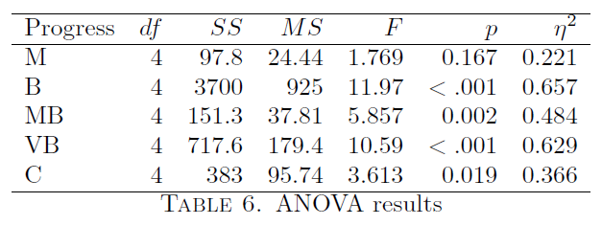

Additionally, the Scheffé post hoc test revealed the following

1. For the middling bin, no schools were significantly different
2. For the behind bin, school pairs (A,B), (B,E), and (C,E) were significant different
3. For the more behind and very behind bins, only schools A and B were significantly different
4. No schools were significantly different for the complete bin.

**Section 3: Conclusions**

With the data provided, it was discovered that school B seemed to have the most success with the course, with the highest percentage of enrolled students complete with their coursework at the ¾ mark, and lowest percentage of enrolled students in danger of not finishing. Moreover, the two smaller schools were not immune to students falling behind. Additionally, results of analysis reveal that the school differences was significantly impacted by the school’s average number of students in each progress bin except for the range of 0 to 5 lessons ahead, and each progress bin had different schools that were significantly different, if any. For example, only schools A and B are significantly different for the more behind bin, but schools A and B, B and E, and C and E are significantly different for the behind bin.

Alas the fully story cannot be told. Only having data for the first ¾ of the semester does not allow for full evaluation of the course because there is no information about how the students ultimately performed. More specifically, because neither the resulting grades nor the final completion counts were provided.

The statements in section 1.2 regarding School B being the “winner” is valid but inconsequential if the performance (i.e. resulting grades) were poor. The continued implementation of this course and its experimental format are contingent upon the students’ performance. However, with this being the first version of the course, it does lend itself to improvement (which would inevitably be needed regardless of student performance). Whether this data can or will be made available (privacy concerns, after all) to allow for a more thorough analysis remains to be seen.

1. This particular issue is perhaps related to the nation’s growing dependence on calculators, but that is a discussion for another time.
2. And to save on typing.
3. Notice that VA is not included, this is due to having no values for any school, so it holds no true value